Generalized linear model (GLM) is a linear regression that allows variables to have error distribution rather than normal distribution. Logistic regression is one of GLM models that solving un-linearized data. In another words, Logistic regression predicts True or False for the target variables rather than continues line of number. Therefore, Logistic regression fits in “S” shaped curve that goes from 0 to 1 rather than upwards on downwards straight line.

For example, we want to classify the probability of customer defaults based on credit information. In default dataset, the target variables have only two outcomes: yes or no. We have met the complex German credit dataset in our previous assignment. In here, I only want to use 4 variables: default on their debt, whether or not a student, credit card average balance, and income. The model of Logistic regression shown as below:

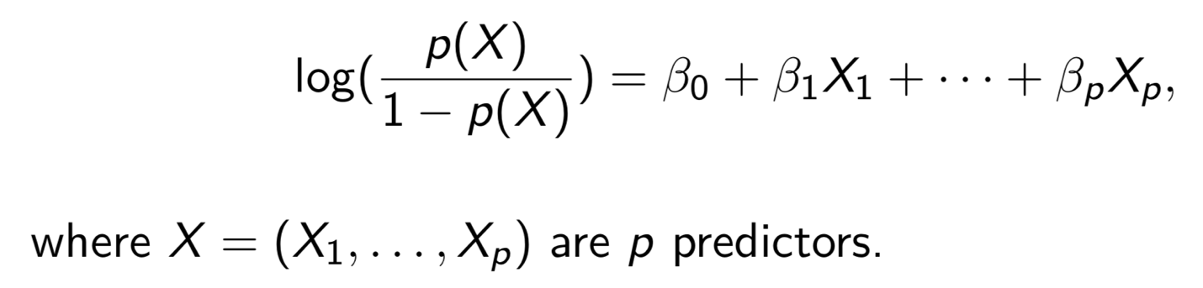

Taking the log of equation, we got:
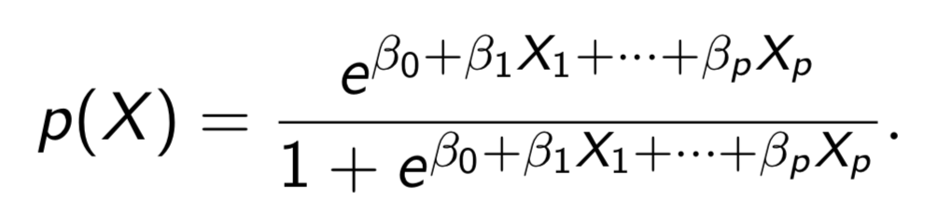

Then we estimate the b0 and b1to maximize the likelihood function by R.

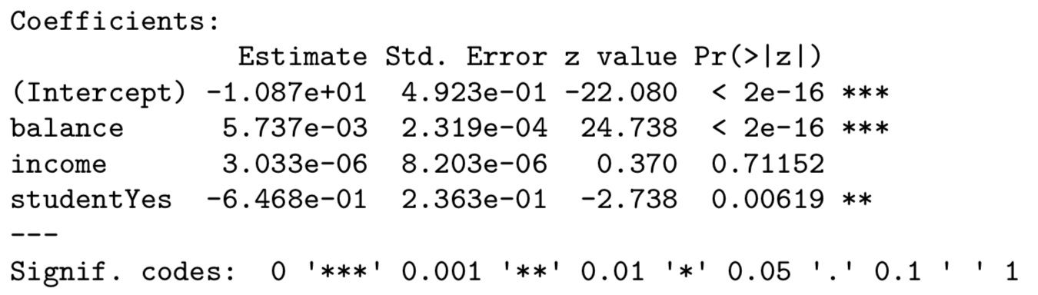
The p-value associated with balance and student are very small, indicating that these two variables are associated with default probabilities. The estimate coefficient value of balance, 0.005737 indicates an increase in balance is associated with an increase in the probability of default.

If we analyze the same dataset using linear regression, the chart will look like this:

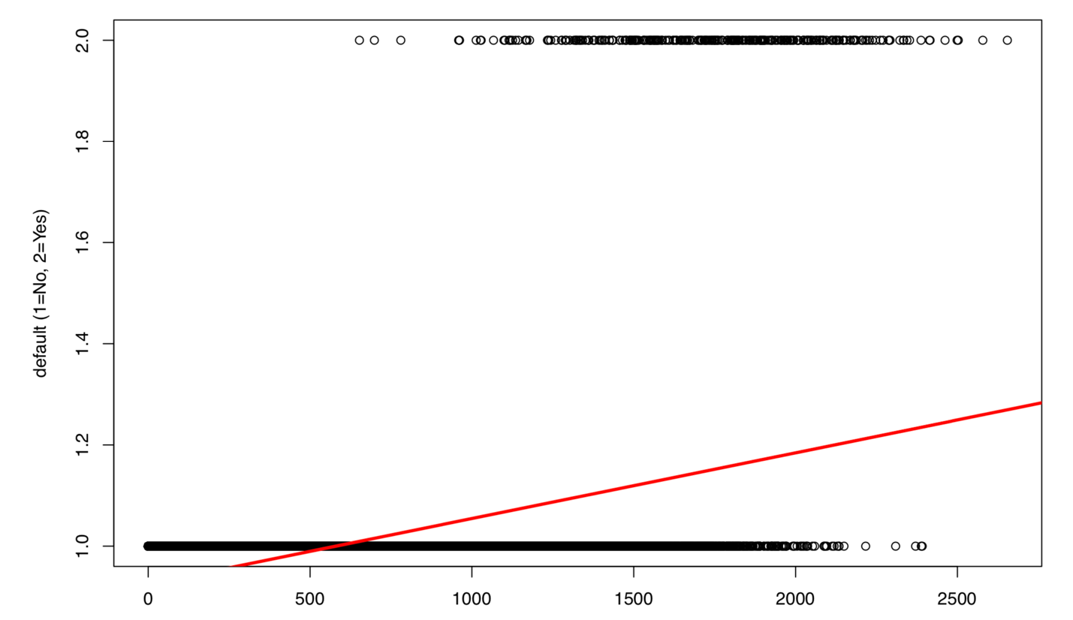

This indicate that a straight line doesn’t fit a binary response well. Logistic regression, on the other hand, belongs to binomial family. The s-shaped curve logistic regression chart shows better capture ability compared to the linear regression model.
